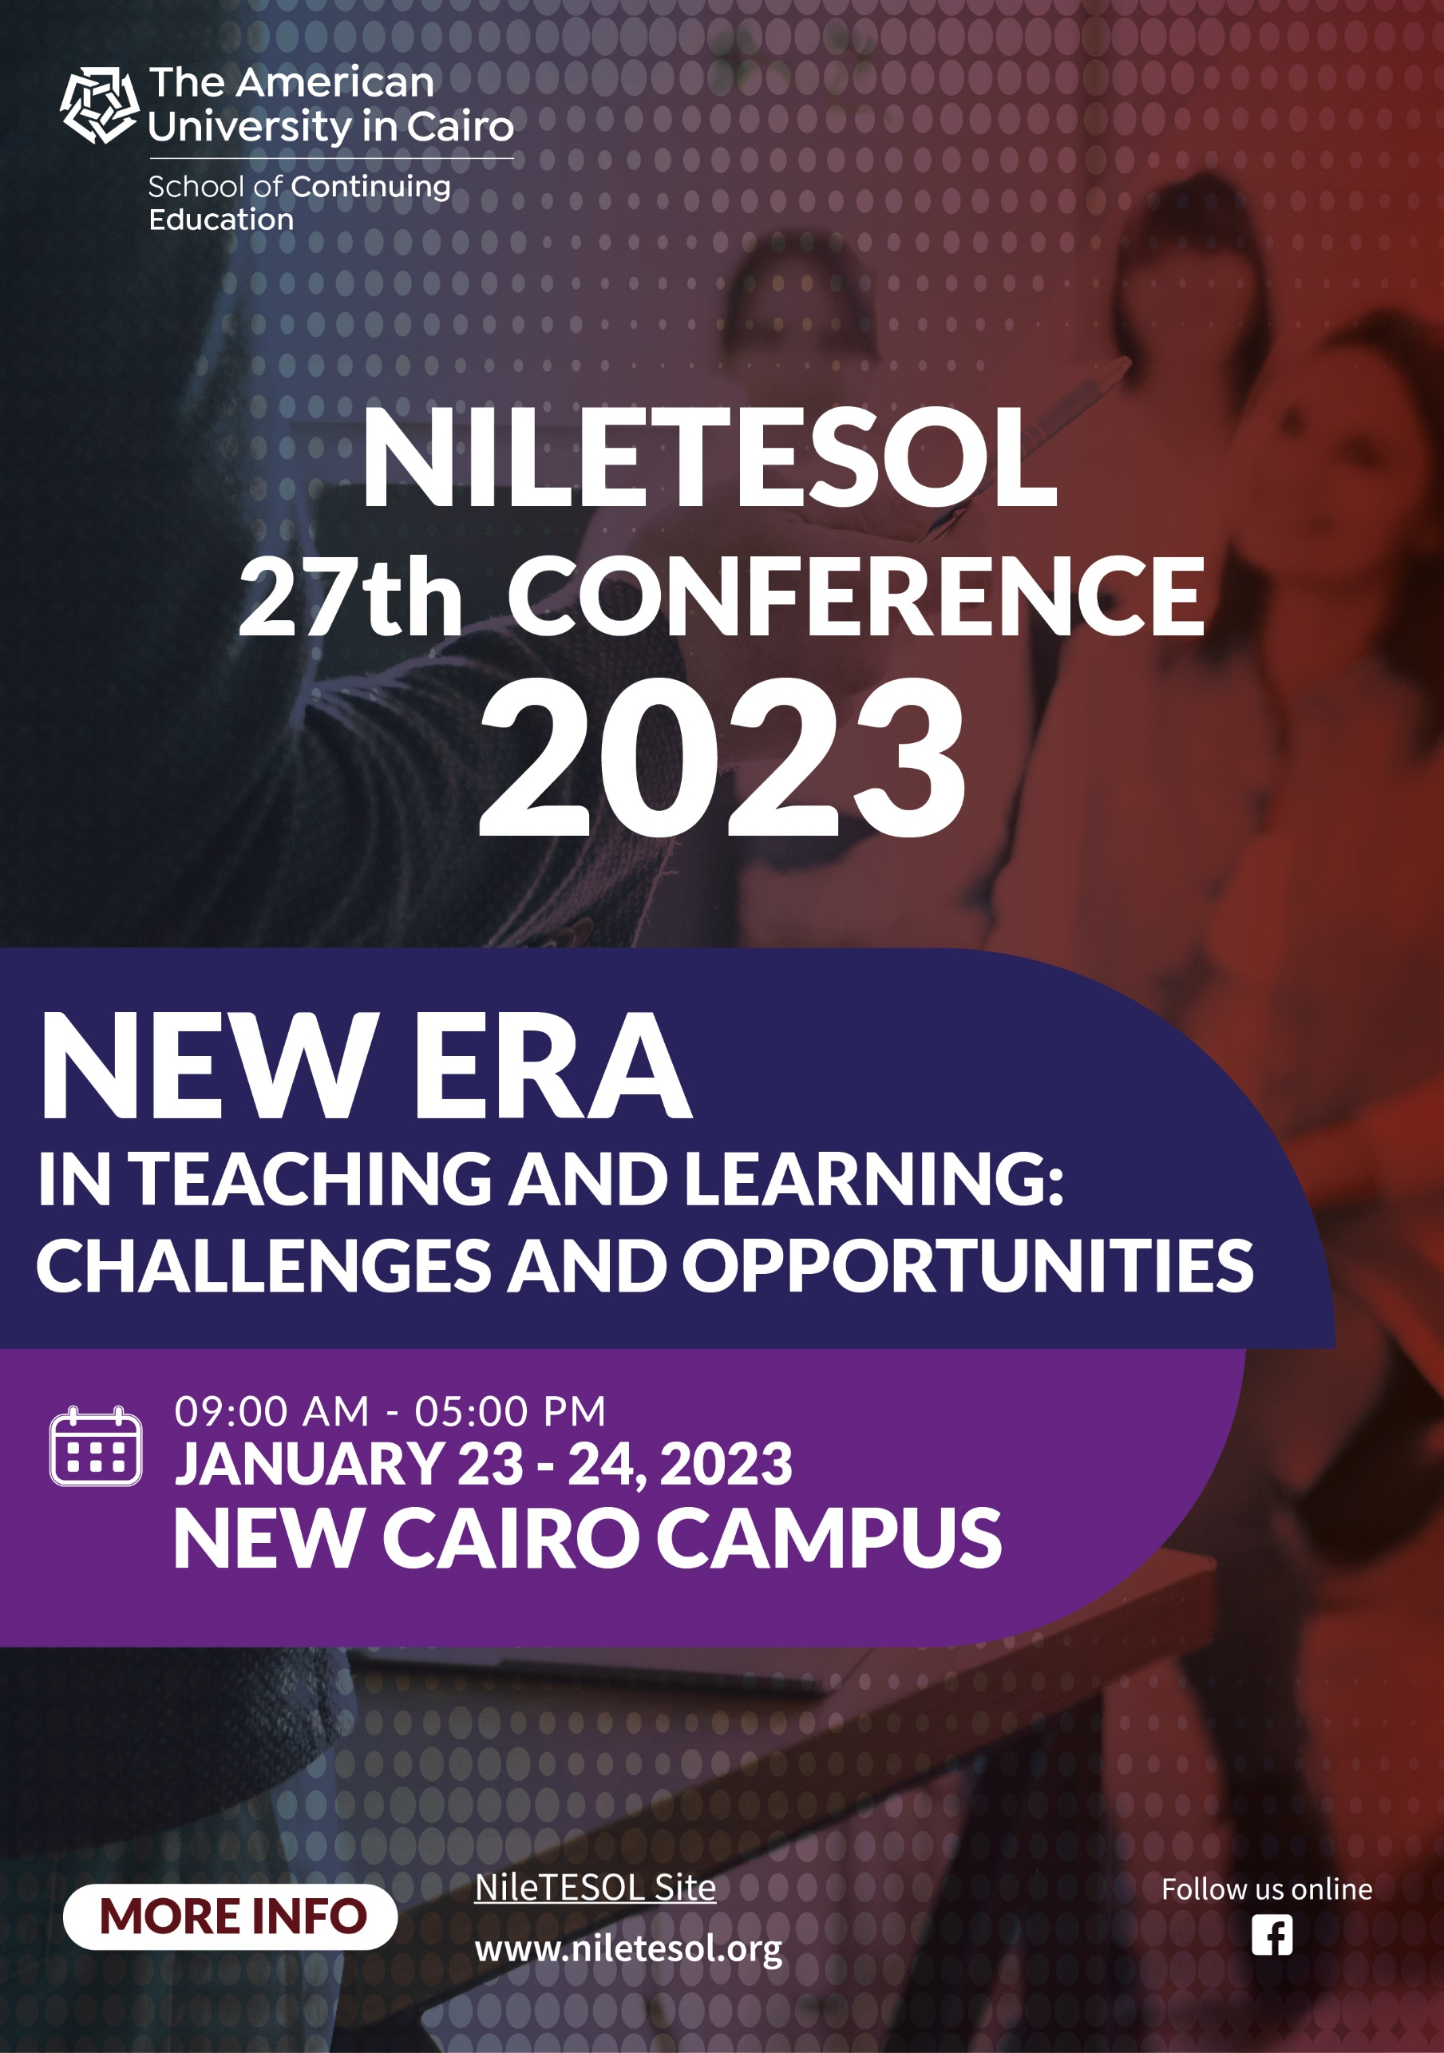

Platinum Sponsors

NileTESOL 2023 Conference
Schedule at a Glance
Day 1 – Monday, January 23rd, 2023
Please note that session times are in Cairo Local Time (CLT) = GMT+2

Rooms | 10:00 - 11:00 | 11:00 - 11:45 | 12:00 - 12:30 | 12:45 - 1:15 | 1:30 - 2:00 | 2:15 - 3:00 | 3:15 - 3:45 | 4:00 - 4:30 | 4:45 - 5:15
P030-Basilly | Opening Ceremony | Plenary  Peter Sokolowski  Mind Your Manners: English Usage for Teachers |  |  |  | Plenary  York Press  Jonathan Hadley  A New Era... But Same Old Challenges?
P034- Alfi |  |  |  | Cairo Book Center & MM Publications  Featured Speaker  Gregg Sotiropoulos  It's Time to Better (Y)our Best!
Mary Cross |  |  | International Language Bookshop  McGraw Hill  Rachel Finnie  English Language Teaching or English Language Toolkit? | Plenary Workshop  Chris Sowton  Practical Activities to Make Your Classroom a Safe, Inclusive, Supportive, Learner-centred Space | International Language Bookshop  National Geographic  Alex Warren  Incorporating ELT Trends into Your Everyday Teaching |  | RELO  Curtis Chan, Chris McDonnell, Hanaa Soudan, Shahinaz Salem, Noha Mazhar, Bassem Elltriby  Informational Session  & How to Find English Learning Resources
Shafik Gabr |  |  | British Council  Hala Ahmed  It's TEA time! A Special Blend for Egyptian Teachers | Pearson  Rania Nazih  English Tests, without the Stress | Nahdit Misr  Nehal Okba  Trends in E-learning Assessment, Challenges and Way for Solutions
P007 (CONFR) |  |  | International House  Laura Woodward  Helping Students Focus in the Class: Increase Motivation and Participation | NT23094  Muhammad Khalil Moussa  Changing IELTS Candidates' Mindset from Scoring to Lifelong Learning | Panel Discussion  Amani Demian  Hager Seddik  Laila ElSerty  Nora Bonnah  Rania Jabr  Incorporating Critical Thinking in the Curriculum
P020 (CONFR) |  |  | NT23043  Rania Jabr  Infographics: A Visual Literacy Tool | NT23170  Laila Youssef Kamal & Mona El Saady  A Recipe for Student Motivation | British Council  Doaa Zakaria  The Relationship between Teachers' Professional Development and Well-being
P022 (CONFR) |  |  |  |  | NT23024  Shady Reda Abuyusuf  To Guide, or Not to Guide, That is the Question |  | NT23154  Hossam El Din Attiah & Aliaa Hamad  Once upon a Time: Storytelling and Narratives in the Classroom
SSE CP19 |  |  | NT23118  Elisabeth Yoder  Criteria for Choosing Technological Tools | NT23105  Hanan Ali Ameen  Developing Learner- Centered Critical Thinking Skills | NT23054  Nesreen Hassan Abdel Hakim  The SIOP Recipe |  | NT23125  Muhammad Abd Allah Mahmoud Ahmed Darwish  It's TEA Time: Teach, Engage, Aspire | NT23143  Safaa Wahid Mohamed Elshenawy  The Effect of Virtual Reality Technology on Teaching Languages | NT23215  Heba Othman  Nurturing Students' Creative Thinking and Problem- Solving Skills
SSE CP20 |  |  | NT23115  Anan AbdElRahman AbdElHamid Ahmed  Teaching Advanced Classes: Challenges & Opportunities | NT23103  Moustafa Elbehairy  Polish the “Hearing” Lantern and Release the “Listening” Genie! | NT23138  Azza Salman  Bringing Climate Change to the EFL Classroom |  | NT23149  Ibrahim Abdellatif Abudhela  Universal Design for Learning: Adapt or Adopt? | NT23007  Aboulmagd Sayed Saleem Moussa  A US Education Exchange Program Recap (A Personal Perspective) | NT23181  Ragaa Mohammad Gomaa ElMorsy  Adding the Magic to The Young Learners' Classroom
SSE CP 21 |  |  | NT23116  Tamer Hussein Ramadan Darweesh  Tools that Maximize Learning and Create Fun inside the Classroom | NT23121  Yomna Youssef Hussein Mohamed Mohamed & Yumna Muhammed Aly Abdullah  Assessment and Feedback: Engendering Motivation and Competence in Blended Learning | NT23131  Refaay Salama Zidan  Reflect to Connect |  | NT23162  Nermeen Nasr Labib  Critical Thinking: Teaching – Testing – Developing | NT23145  Walaa Mohammed Abed Aziz Khattab  Revisit the Inclusive Education Concept: A Speaking Deaf Case Study | NT23031  Fathy Moustafa Kamal Afify  How to Make Free Offline Interactive Exercises for Students
SSE CP22 |  |  | NT23127  Mai Sayed Moanis  Tools for Developing Autonomous Learning: Logbooks and Blogs | NT23111  Nada Yasser Sayed Ahmed El-Metwally Ibrahim & Nagwa Younis  An Ace Up my Sleeve: A Fiction-based Approach to Enhance Speaking Skill | NT23191  Ahmed Essam Ahmed  Using Integrated Activities and Skills to Enhance Students' Speaking Proficiency |  | NT23093  Essra Mahmoud  Visible Thinking Strategies to Enhance 21st Century Skills | NT23122  Osama Elbeyaly  "Let's Talk about Your Lesson": Genre Analysis of Trainers' Feedback | NT23123  Shereen Ahmad Zeyady & Sarah Moussa  DIY: A Stress-Free & Productive 21st Century Classroom
SSE CP23 |  |  |  | NT23006  Rasha Osman Abdel Haliem Osman  Post-pandemic Integration of Educational Technology: Challenges and Best Practices | NT23011  Ahmed Abdelhai  Materials Development in Egyptian EFL Classrooms: A New Vision |  | NT23098  Mohamed Osama & Sarah Elkasabi  Differentiation with ICT Integration | NT23114  Heba Anter Abdel Samea Sallam & Eman Ahmed Abdel-Fattah Ali  How is Mentoring Supported by Teaching Experience? Turning Challenges into Opportunities
SSE CP25 |  |  | NT23015  Mohammad Nabil Mohammad  How to Get Your Students to Become Their Own Teacher? |  | NT23206  Soheir Mostafa Ahmed Mohamed Albahrawy  Classroom Management Strategies to Boost Student Engagement |  | NT23018  Nada Mohsen Said Ali Sherif  Creating Student-Centered Lesson Plans Using Learning Designer Free Website | NT23117  Shaimaa Hussien Elharty  Turn Vocabulary Practice to an Online Game in 5 Minutes | NT23107  Mahinour Salama  Teaching 21st-Century Skills from Theory to Reality
SSE CP29 |  |  | NT23169  Sa'eed Hassan  Integrated English Language Teaching Framework in Practice | NT23050  Samir Omara  Backward Design in Language Teaching | NT23219  Eman Gamal Eldin Ibrahim Mohamed  Why Not Give Podcasts a Try in EFL Classes? |  | NT23079  Muhammad Moustafa AlSaeed AlQadi  Using L1 in Teaching L2: Contrastive Analysis Approach | NT23171  Samah Ahmed Maghawry & Hebat Talat Mostafa  SIOP in Action: Make Content Comprehensible | NT23205  Eman Hussein Abdelsalam  The Right Pedagogy for Digital-Natives, Does It Ever Exist?
SSE CP31 |  |  | NT23077  Kamila Mostafa Helmy  Reading in EFL Classrooms: Challenges and Strategies | NT23203  Susanne Rizzo & Mariah Fairley  Exploring Our Language Teacher Identities: Self-Reflective and Discussion Activities | NT23038  Ehab Elshimi  Developing Critical Reading Skills through Engaging Activities and Reflective Writing |  |  | NT23092  Muhammed Zakaria Wafa  Cooperative Learning Structures and Application | NT23078  Somaia Hamdy Abdelmotalb Elnaggar  Online Toolkit in Designing ESL Materials
SSE CP35 |  |  | NT23101  Maha Hosny Awad & Sherihan Ahmed Morsi  No Child Is Left Behind | NT23057  Youssef Laaraj  Students’ Perceptions of Blended Learning in Moroccan Universities during COVID Era |  |  |  | NT23059  Ramy Mohamed Samir El-Din Ayad  Genially: Create Interactive Content for Online, Blended, or Face-to-face Classrooms | NT23081  Aya Muhammad Khedr Muhammad  Classroom Management: EFL Beginning Teachers in Action Learning Sets
SSE CP38 |  |  |  | SIGs Poster Sessions |  |  | Poster Sessions
SSE CP39 |  |  |  | SIGs Poster Sessions
HATEM C116 |  |  |  |  | NT23204  Faten Saad Mahmoud Ali  Effective Teaching of Reading in a Classroom |  | NT23060  Shereen Mahfouz Mohamed Mohamed  Implementing Collaborative Learning Approach to Develop the 21st Century Skills | NT23148  Mai Ahmed Eassa El Nekhely  Innovative Techniques and Useful Tips for Classroom Management | NT23126  Mohamed Adel  How to Master Giving Feedback
HATEM C117 |  |  | NT23128  Mohammed Adel Hussein  An All-Inclusive Classroom: A Practical Guide to Teaching Mixed-Ability Classes |  | NT23224  Hala Mourad Tadros  Teachers Need to Teach Beyond Their Own Learning Style |  | NT23061  Tahany Rushdy Ali Soliman  Creative and Quick Ideas for Classroom Management | NT23188  Safinaz Hussein Hamed  OER: A Chameleon in the Classroom | NT23167  Amany Safwat Kheriba  "Help!" Cried Mother Earth: Educational Activities for Teaching Environmental Issues

NileTESOL 2023 Conference
Schedule at a Glance
Day 2 – Tuesday, January 24th, 2023
Please note that session times are in Cairo Local Time (CLT) = GMT+2

Rooms | 9:00 - 9:45 | 10:00 - 10:30 | 10:45 - 11:15 | 11:30 - 12:00 | 12:15 - 12:45 | 1:00 - 1:45 | 2:00 - 2:30 | 2:45 - 3:15 | 3:30 - 4:30
P030-Basilly | Plenary  Chris Sowton  Addressing Today’s Challenges – and Accessing Tomorrow’s Opportunities – in the World of ELT |  |  |  |  | Plenary  Hala Abd El Hak  Shared Spaces, Lessons Learnt: Inclusion in the Post-COVID Era |  |  | Closing Remarks
P034- Alfi |  |  | International Language Bookshop  National Geographic  Featured Speaker  Alex Warren  Critical Thinking with Visible Thinking Routines in the English Language Classroom |  | British Council  Iman Diaa, Yomna Ibrahim & Ayat Al-Tawel  Introducing British Council CELTA & pre-CELA programs
Mary Cross |  | English Score  George Eiloart  Utilizing the Power of AI in English Assessment at English Score | Plenary Workshop  Peter Sokolowski  Learning Vocabulary Using the Dictionary |  |  |  | RELO  Curtis Chan, Peter Sokolowski, Hanaa Soudan, Shahinaz Salem, Noha Mazhar, Bassem Elltriby  Mini Spelling Bee Competition for Teachers
Shafik Gabr |  | York Press  Plenary Workshop  Johnathan Hadley  Finding Solutions to Old Challenges | Pearson  Hemani Naran  Keep the Ball Rolling! Maintaining Motivation in the ELL Classroom (K-12) |  |  |  |  | Panel Discussion  Afaf Mishriki  Ahmed Farouk  Ahmed Shalaby  Deena Mansour  Mona Addeq  Lessons Learnt from Online Teaching and Learning
P007 (CONFR) |  | International House  Hamed Sherif  Communicative Speaking Activities |  |  | International House  Laura Woodward  Early Childhood Teaching: Learning through Play and Storytelling |  | Q & A with NileTESOL President  Sanaa Makhlouf
P020 (CONFR) |  | NT23147  Fayyaz Malik  Teaching Compare and Contrast Essay: From Known to Unknown! |  |  | NT23035  Afaf Mishriki & Amani Demian  Lessons Learned: The Silver Lining of the Pandemic
P022 (CONFR) |  |  | NT23180  Laura McWilliams &  Sarah Smith  Building Resilience: Desirable Difficulty in the Young Learner Classroom | Cairo Book Center & MM Publications  Eglal El Gamel  21st Century Skills in the ELT Classroom
SSE CP17 |  | NT23229  Manal Hassan Elbanna Mohamed  Lifelong Learning in Action |  | NT23163  Amira Hassan Khalil Hassan  Non-Native English Teacher: Ambassador or Imposter? | NT23158  Rasha Anwar  Bridge the Gap: Sound Like a Native Speaker |  | NT23151  Ayat AlTawel  The Teacher Support Program: Going Beyond Theory and Practice | NT23005  Mohamed Abdellatif Elzoghby  Praxis of Meta -cognitive Strategies to Enhance EFL Reading
SSE CP19 |  | NT23072  Dalia Mohamed Saada  Promoting Learners’ Autonomy for a Lifelong Learning | NT23232  Nesma Kamal Mohamed Ibrahim  Let’s Enjoy Using the Magic Tool PlayPosit | NT23196  Eman Elsayed Eltaher Mahmoud Abdelhalim Fathallah  The 21st Century Skills to Build Our Learners' Future | NT23129  Hoda Mohamed Gamil Abdel Hakim  Help! The Teachers Are Burning out! |  | NT23200  Sally Abdelhady Mancy  Parent Involvement: Effective Practices to Enhance Student Success | NT23019  Lotfy Abdullateef Abdulwahab El-bagoury  A New Definition of the Teacher
SSE CP20 |  | NT23075  Salwa Yassin Abou Hadid  Changing Class Dynamics to Avoid Monotony |  | NT23066  Hala Desoky  Using Technology in a Meaningful Way to Amplify Learning | NT23220  Eman Bekheet Abdelsabour Mohammed Bekheet  Gap Bridging through Translanguaging |  | NT23213  Fatma Mohamed Zoghlof  Humanization of Education in the Age of Teacher-Learner "Contractual Relationship" | NT23029  Hesham Mohammed ElSayed Abu Mostafa  M-Learning and the Toolkit of an Innovative Pronunciation Trainer
SSE CP21 |  |  | NT23097  Shereen Abdel Fattah Nassef  Motivational Material for the Swift Charming Online Age | NT23096  Dina Alaa Elsayed  Scaffolding Project -Based Instruction - Opportunity to Acquire Language | NT23095  Moein Ahmed  Increasing Students’ Efficiency in Post-Pandemic Classroom |  | NT23133  Eman Moustafa Muhammed  Harnessing Crafts to Enhance Linguistic Competence and Performance among Children | NT23086  Hamed Ashraf & Alshaimaa Alshafeay  The LSSR Approach: 4 Keys to Boost Learners’ Listening Level
SSE CP28 |  | SIG Session  (EIE-SIG)  Maha Hosny  Old Struggling Readers Are Not Struggling Anymore | NT23110  Amira Salama  Understanding Teacher Wellbeing Challenges and Opportunities | NT23040  Louis David Train  Online Learning and Language Anxiety: How Camera Policies Impact Outcomes | NT23165  Nesrin Mohamed Imam Ibrahim, Monica Naguib, Marwa M. Abdelhalim, Amira Salama, Amany Y. A. A. Youssef  Project-based Teaching and Learning in a Graduate Course in Linguistics |  | SIG Session  (LT-SIG)  Heba Othman & Ghada Wasef  Tech Tools to Foster Higher-order Thinking Skills in the Classroom
SSE CP29 |  | NT23240  Yasmine Salah El-Din  Google Slides: One Size Fits All | NT23012  Eric Gondree  Helping EFL Students to Think Historically | NT23195  Noura Nabil Soliman  Project-Based Learning: Why Student Groups May End up Ungrouped? | NT23083  Abdelrahman Mohammad El-Adl El-Morsi  Gamification and the Motivation, Engagement, and Academic Performance of Young Learners |  | NT23156  Amina Sabour  EFL Teaching for Sustainability | NT23036  Randa Adel Alsayed Ali  A Gaming Environment Reunites Different Mindsets to Provide an Applicable Platform
SSE CP30 |  | NT23048  Rania Zaki Ahmed  Comic Strips and Storytelling Tips: Developing Productive Skills | NT23014  Mariam Makramalla  Widening the Definition of Distance Learning for the Egyptian Context |  | NT23216  Mahmoud Selim  Getting Students to Speak up: Activities to Enhance the Speaking Skill |  | NT23201  Anas Mahmoud AbdElGawad ElNahriry  Tokkatsu: Special Activities for Student Engagement, Collaboration, Interaction and Creativity | NT23124  Azza Adel Soliman  Mirror, Mirror on the Wall!
SSE CP31 |  | NT23176  Noha Nagy Mahmoud Hussein  Using Blended Learning to Promote Lifelong Learning | NT23168  Mai Sobhy Nouraldine Aish &  Sondos An-nagar  Autonomy- Supportive Teaching's Malleability in Improving Students' Practices & Ownership | NT23227  Mustafa Mohamed Hussein  Using Artificial Intelligence in Identifying Classroom Weaknesses |  |  | NT23186  Mostafa Zaki  Techniques for ESL Instruction Applied in Action: Less Effort, More Production | NT23223  Shrouk Ahmad Muhammed Anany  On Teachers' Mental Health: Face the Burnout
SSE CP32 |  | NT23166  Abeya Shawky Mohammed El Bakry  What's Missing for the 21st Century in Egyptian Schools? |  | NT23034  Amany Hussein El Desouky El Said Kasab  Game-Based Learning and Climate Change (Internationalizing Education) | NT23020  Noha Abu Karam  The WBT Technique: A New Successful Trend in Managing Classrooms |  | NT23039  Israa Khamis Osman  Digital Teaching and Learning: From Theory to Practice | NT23047  Hesham Mohammed  Digital Tools for Interactive Online Teaching & Learning
SSE CP33 |  |  |  | NT23058  Walaa Mohamed Semaisem  The Texan Clue for Our Challenging Cross-curriculums | AUC - SCE  Professional Development Offerings at AUC's School of Continuing Education  Amira El-Deeb |  | NT23088  Natalie Trangmar  Which English(es) Should We Be Teaching? | NT23187  Yasmeen Abdelazeem Muhammad Saif  Materials Development with Relation to Teaching Main Components
SSE CP34 |  |  | NT23140  Rashida Ali Saad Mahmoud  Dynamic Activities to Develop Your learners' 21st Century Skills | NT23137  Sabrin Abdelgawwad Amin Abu Ali & Jabber Hassan  Online Teaching in Egypt Challenges and Opportunities | NT23142  Hebatallah Morsy  How Can Teachers Maintain a Positive Classroom Environment While Integrating Phonology? |  | NT23119  Erieny Habib & Bassant Shenaf  How to Better Include Special Educational Needs (SEN) Students | NT23132  Hala Ibrahim Mohamed Gharib  Let’s Dig Deep into the “Styles and Strategy-Based Instruction” Approach
SSE CP35 |  |  | NT23161  Walaa AbdelFattah Ahmed Salem &  Maged Rushdy  Flipgrid to Support Equity, Diversity, and Inclusion with Access Program | NT23159  Shaimaa Muhammad Magdi AlDahshan  Getting Started with Fun | NT23226  Rania Al-Shater  Graphic Facilitation in ELT: The Innovative Power of Cogenerating Understanding |  |  | NT23045  Amira Al-Basiony  Collaboration with Refugees Centers to Enhance Students' Engagement in the Learning Process
SSE CP38 |  |  |  | SIGs Poster Sessions
SSE CP39 |  |  |  | SIGs Poster Sessions

